Qatar university
College of engineering
Department of computer science and engineering

CMPS310- Software Engineering

Milestone 1 Report
PrearlMart inventory Management System

Prepared by:
Laraib khan
Kaltham alkubaisi
Noof alyafei

Instructor:
Eng. Fatima Hamza

Submission date: 18, October 2026

Section: B52

- Scrum responsibilities

Role | Member
Product owner | Eng. Fatma Hamza
Scrum master | Kaltham alkubaisi
Developer | Noof alyafei
Developer | Laraib khan

- Product Goal
to develop an inventory management system for pearlMart that helps authorized employees efficiently manage inventory, supplier order, sales, and related transactions while maintaining accurate records and supporting inventory reporting.

- Definition of Done
a work is considered done when:
- It meets the project requirements.
- It has been reviewed by at least by at least one member
- Any identified errors have been corrected
- The final version has been saved and uploaded to the team’s GitHub repository in the main branch

- Assumptions:

- Assumption1: The inventory manager is the authorized employee responsible for performing inventory management operation including adding, removing, searching, and updating inventory item information
- Justification: to clearly define the responsibilities of the inventory manager and avoid ambiguity regarding which employee is authorized to manage inventory records
- Affected models: Data flow diagram level 0,1,2 and use case diagram

- Assumption2: The authorized managers who can request summary reports are the inventory manager and the store manager
- Justification: Both managers have management responsibilities and need access to summary reports to monitor inventory and store activities
- Affected models: Data flow diagram level 0,1,2 and use case diagram

- Assumption3: Expiration date is an optional attribute of Item ([0..1]). An item with no date doesn’t count as expired
- Justification: The project requirements doc said the date is recorded “when applicable”
- Affected models: Class Diagram

- Assumption4: StockMovement records only manual additions, removals and expired-goods removals. Supplier deleiveries recorded on SupplierOrder, sales on Sale and replacements on Repkacement
- Justification: The project requirements doc said “goods added or removed” as tracked activities
- Affected models: Class Diagram

- Assumption5: Delivery verification is stored on SupplierOrder (as receivedDate) and OrderLine (as receivedQuantity), so there’s no separate Receipt class.
- Justification: The project requirements doc said the store manager verifies the goods and the system “records the received quantities”
- Affected models: Class Diagram

- Assumption6: Discount and tax are calculated per sale line
- Justification: The project requirements doc gave no info on rules and rates, so I treated them as calculation logic
- Affected models: Class Diagram

- Assumption7: Only accepted replacements are stores and the accepted replacements hands out the same item so its quantity is deducted from the stock
- Justification: The project requirements doc said “necessary updates to the inventory” so I feel its necessary
- Affected models: Class Diagram

- Sprints review

- Sprint1

- Sprint retrospective

Duration: September18 – October 2 ,2026

Goal: develop initial system analysis model for the pearl mart
inventory management system

Backlog: create DFD level 0, DFD level 1, DFD leve2

- Sprint review

Completed work: During Sprint 1, the team completed the DFD Level 0, Level 1, and Level 2.

Feedback: Team members reviewed the diagrams and provided feedback regarding spelling mistakes, missing methods, and missing use cases. These comments helped the team identify areas that needed improvement.

- Sprint retrospective

Difficulties: The main difficulty faced during Sprint 1 was limited time, which made it challenging to complete and review all tasks efficiently.

Improvement actions: To address this issue, the team decided to improve time management by organizing tasks more effectively and allocating sufficient time for reviewing and correcting the diagrams in Sprint 2.

- Sprint 2

- Sprint retrospective

Duration: September3 – October 17 ,2026

Goal: to continue developing the pearlMart system models, complete the remaining design tasks, and improve the quality and consistency of the project deliverables.

Backlog: create the use case diagram and the use case specification tables, and the class diagram.

- Sprint review

Completed work: During sprint2 the team worked on the use case diagram and specification tables and the class diagram.

Feedback: t Team members reviewed the diagrams and provided feedback regarding some additional redundant classes and some weak alternatives flows.

- Sprint retrospective

Difficulties: the main difficulty
Improvement actions: the team focused on improving task organization and allocating more time for reviewing and correcting project deliverables, as planned after sprint1. team members agreed the the initial draft must be submitted at least 2 days before the deadline to allocate more time to review.

- DFD level-1
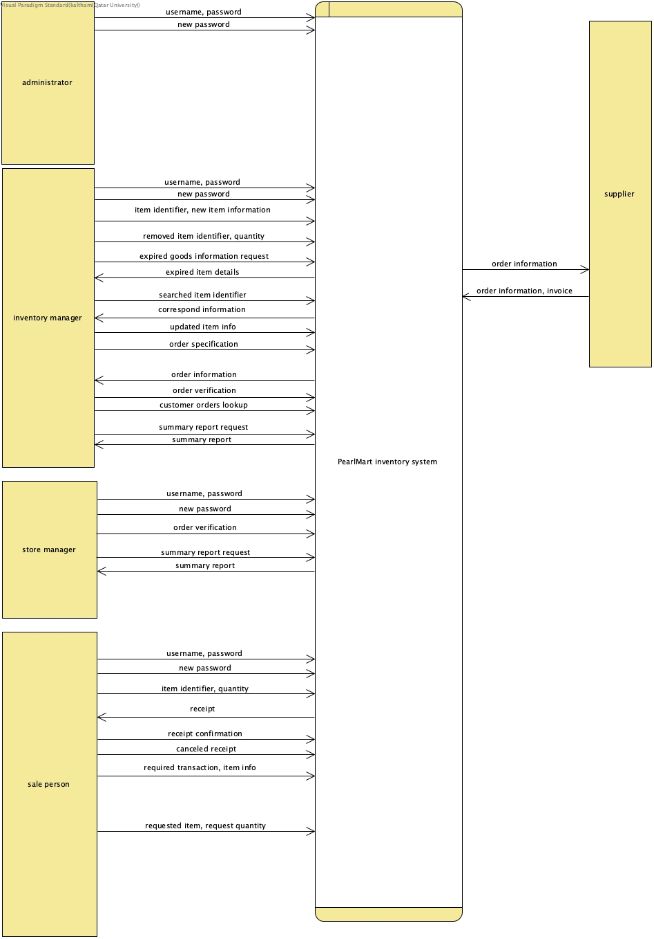

- DFD level 1:

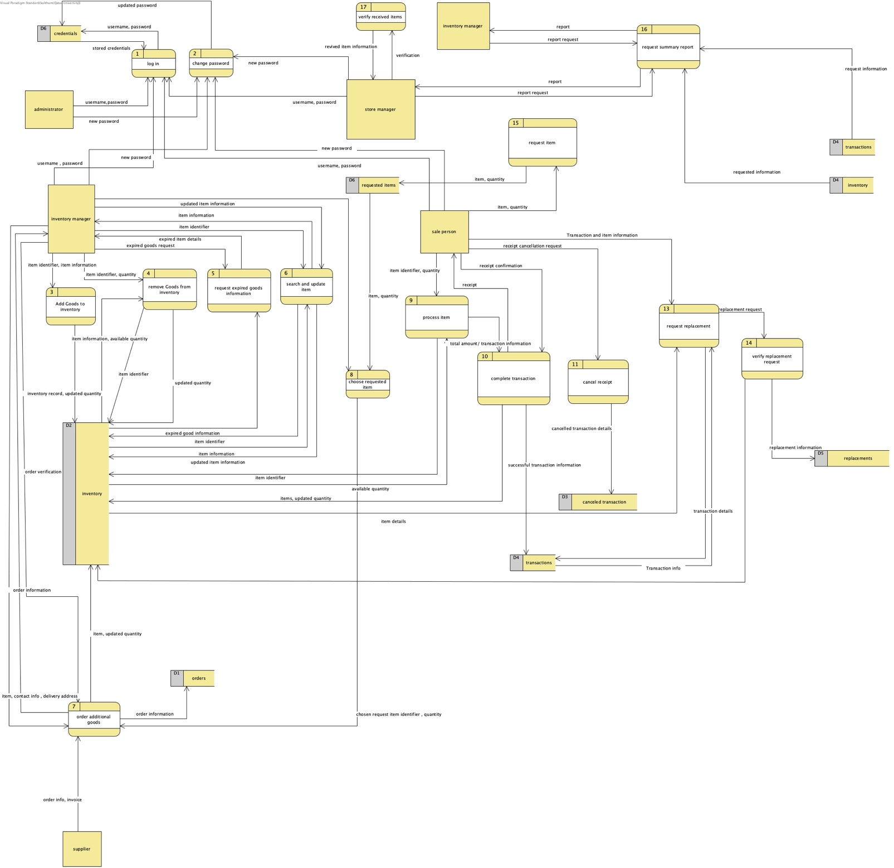

- DFD level 2
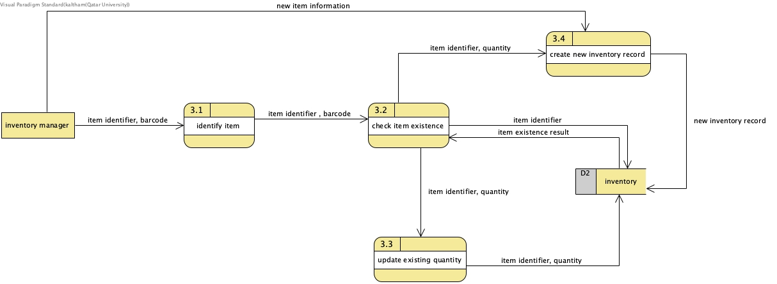

- DFD checklist

DFD comparison | Boundary flow verified | Balanced
Level0⇔ level 1 | external input and output data flows are preserved | Yes
Level1⇔ level 2 | external input and output data flows are preserved | Yes

- Use Case diagram:
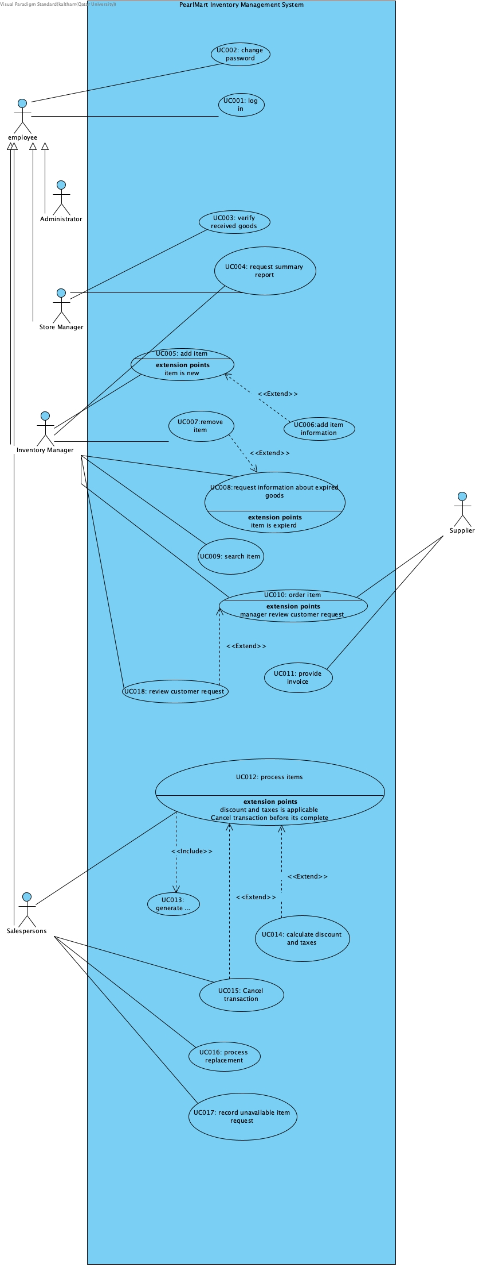

- DFD and UseCase comparison:

The DFD and Use Case Diagram show different parts of the PearlMart Inventory Management System. The DFD shows how data moves through the system, including the processes, external entities, and data stores. For example, it shows how item information is received and used when adding or updating items in the inventory. The main advantage of the DFD is that it helps us understand how data is processed and where it is stored. However, it does not clearly show the functions available to each user. On the other hand, the Use Case Diagram shows how different actors interact with the system and what functions they can perform. For example, it shows that the Inventory Manager can add and remove items. Its main advantage is that it makes the system functions and user roles easier to understand. However, it does not show how data moves inside the system or how it is stored. Both diagrams are useful because they explain the system from different perspectives. The Use Case Diagram shows who can use each function, while the DFD shows how data moves between the different parts of the system. For example, if we want to know how item information moves through the system when adding a new item, the DFD is more useful because it shows the data flows and processes involved. The Use Case Diagram only shows that the actor can perform the Add Item function

